# Day 1 - Plan and Set Up Networking

**Role focus:** Azure & AD Admin

1. **Create the resource group.**
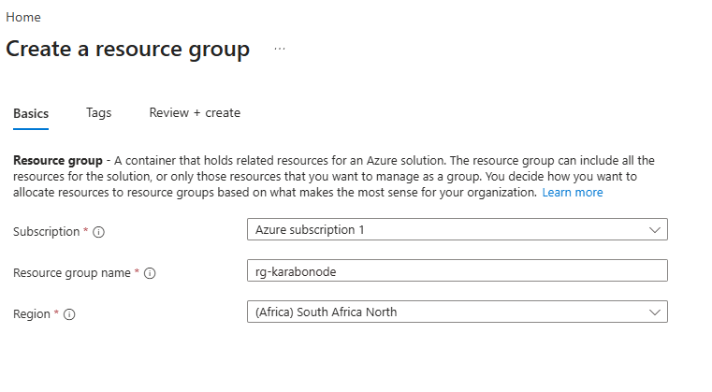

2. **Create the VNet.**
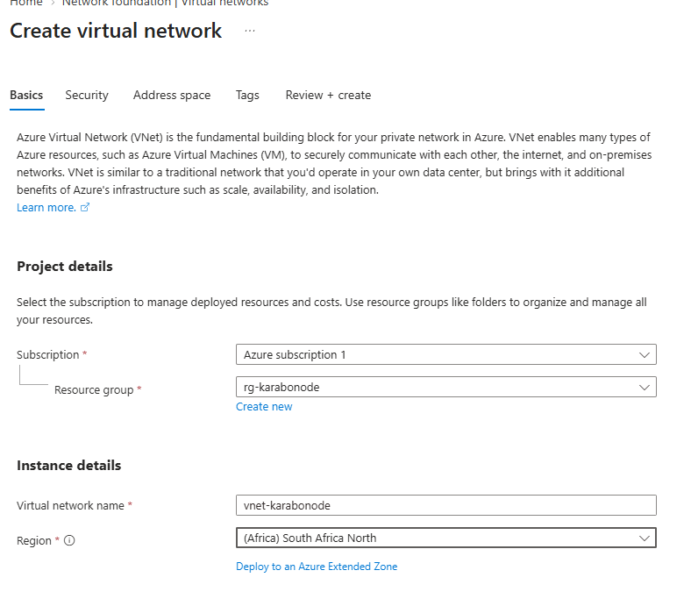
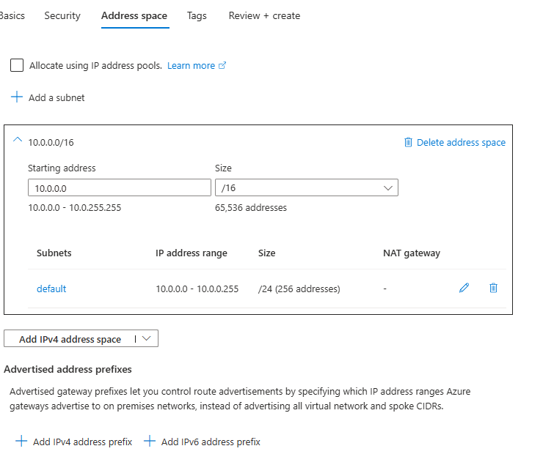

3. **Re-read core AD vocabulary** before you build anything — you'll use all of it this week:
- **Forest** — the top-level AD container; one or more domains sharing a common schema and Global Catalog
- **Domain** — an administrative/security boundary inside a forest
- **Domain Controller (DC)** — a server holding a writable copy of the AD database and running AD DS
- **OU (Organizational Unit)** — a container for organizing objects and delegating admin rights or linking GPOs; not a security boundary
- **GPO (Group Policy Object)** — a set of policy settings linked to a site, domain, or OU
- **SYSVOL** — a shared folder replicated between DCs, holding GPOs and logon scripts
- **NTDS.dit** — the actual AD database file on disk
- **FSMO** — the 5 special single-master roles (below)
- **DSRM (Directory Services Restore Mode)** — a special boot mode used for AD database maintenance/recovery

